**Interview Process**

Our device is a smart dog collar that allows the owner to interact with their dog while they are away from each other. This unfortunately constrained the extent to which we could perform contextual inquiry on our target group, since it’s difficult to create a situation where a dog owner would want to interact with their dog remotely. Instead of direct observation, we interviewed dog owners in attempt to become experts on dog ownership. We’ve focused on understanding the specific problems dog owners encounter when taking care of their dogs.

**Interview #1 Notes (from Garrett):**

# **Background**

* Has two dogs, a Dachshund and a Pomeranian
* Anthropology major
* Lives in El Cerrito (commutes to campus)
* She wants less stuff!
* Doesn't own any smart devices except for
  + Chrome cast
  + Bluetooth speaker in car
    - Really likes it
* Wants
  + Smart sleep alarm
    - But a special sleep device seems kinda silly.

# **Problems with dog ownership**

* Forget when they have to pee
  + Suggestion: Notifications when they stand in front of the door
* Eat things they shouldn't
  + Suggestion: Notifications when they're in a room they shouldn't be.
* Doesn’t want to have to walk their dog
* Food control.
* It's hard for her to leave because the dog freaks out.
  + He knows the sound of your shoes walking the down the stairs
  + He knows the "good bye" language
  + He knows when you pick up your bag...

# **How she interacts with her dogs**

* Doesn't care about shocking her dogs
  + but might be a concern for injured dogs
* No noise complaints
* Name and phone number already on their collar
* They are also chipped.
* Never made use of the collar or chip.
* Bathing
  + They don't like baths
  + Bathe them once a month
  + In a bathtub.
* Doesn't interact with her dogs that much
  + But she interacts with them while walking, and in the living room, etc.
  + and walks them
* Lives in a house with an enclosed back yard
  + Just lets dogs outside when they have to go.
  + ~ 5 times a day.
  + Sometimes they just go outside to bark
  + But she doesn't care.
  + Might be cool to have an automatic door
* Walks her dogs every day
* Toys:
  + Her dogs wouldn't chase a laser pointer, or a tassle or anything
  + They don't really play with toys.

# **Potential pitfalls of our concept**

* It would have you remind you to use it. You may forget about it.
  + Wouldn't use it if you always saw that he was asleep.
* Doesn't actually care what her dog is doing

# **Suggestions**

* Dogsitting:
  + Would be good for a doggy hotel scenario.
  + Not so useful if you're dropping your dog off at your friend's place
  + But if your friend is visiting, that would be cool
* Find a way to make her dogs stop eating so much

**Interview #0 (Anna, Andrew, Garrett)**

Our first interview was with a Berkeley student in a cafe. She lives at home and has two dogs, a Dachshund and a Pomeranian. When asked what the hardest thing about being away from her dogs all day was, she didn’t seem to respond in a way that indicated that she really cared what her dogs were doing while she was away, only that they weren’t eating her clothes. She also wanted a way to know when her dogs wanted to be let out (as she sometimes wouldn’t realize when they were standing at the back door). Her dogs are both chipped and both currently wear a collar, but they’ve never had to rely on either method, as the dogs have never gotten out of her fenced backyard. Though we thought that interviewing her when she was away from her dog would put her more in the mindset of actually needing to use the application that we’re going to build, it seemed much more like an out-of-sight, out-of-mind issue for her. She said she might forget to use it, as she doesn’t currently go through any sort of routine to check up on her dogs while away. She did, however, say that she wanted a way to make sure that her dogs aren’t eating more than they should, which came up in other interviews as well.



# **Interview Note #2 (Eric & Andrew)**

Background

* Has two dogs, Poodle and a Hound
* Just got a smartphone

Problems with Dog Ownership

* dog has separation anxiety
  + dog calms down with music, so wants a way to play music through collar
  + dog barks like crazy when mailman comes

How he interacts with his dogs

* Feeds the dogs by dumping dog food into food bowl and refills when empty
* Trains his dogs using a $90 collar that plays sounds
* Owns a $450 designer collar
* Takes off collar every three months to change battery
* Loose collars that make noise are annoying
* Has to clean his dogs drools when they get on collar
* Wants a space/pocket for the dog license and tags in the collar

This man just got a smartphone, so he’s still learning the ins and outs of smart technology, but already owns a $450 designer collar, and a $90 collar that plays sounds (so he’s willing to spend money on his dogs, a Poodle and a Hound, for things like this). One of his dogs has separation anxiety, so a big thing that he would like to do is be able to play soothing music or sounds for the dog while he was away. One of his dogs also barks at the mailman incessantly.



**Interview Note #3 (Eric & Andrew & Anna)**

Background

* Web Site Designer

Problems with Dog Ownership

* Hard finding dogs at night
* Stressful thinking about dogs all the time

What she wants

* A way to know what the dog is doing when away from home
* Moving to new house so wants bark sensors
* Buzz Collar to train the dogs
* GPS to track at the park
* A way to find the dog in the dark- right now they use lights on collars but it’s hard to know which light is your light
* Maybe a way to check the dog’s temperature/health signs to see if he’s running a fever
* A way to know when the dog is anxiously moving around
* To know when the dog is climbing on the furniture
* Make sure the lights are on while the dog is home (RFID?)

This woman was a web designer, so was very interested in the idea of a smartphone application that integrated with a dog’s collar and other mannerisms. She struggles constantly with finding her dog: while at home, on hikes when he goes off the trail, and at the park when it’s dark outside. She really would like to be able to know where her dog is at all times. She also is very concerned for her dog’s well-being and safety, so would like to know if he was running a fever or any other indicator that he might be ill. When she goes away, she puts the dog in a doggie hotel, and claims that the video feeds they have make her anxious, because she’s constantly checking and making sure Donut looks happy, well-fed, and socialized. She’s moving soon, and is concerned about training the dogs not to jump on furniture, bark at the mailman, etc. She wouldn’t mind shocking her dogs if they needed it for behavioral reasons.

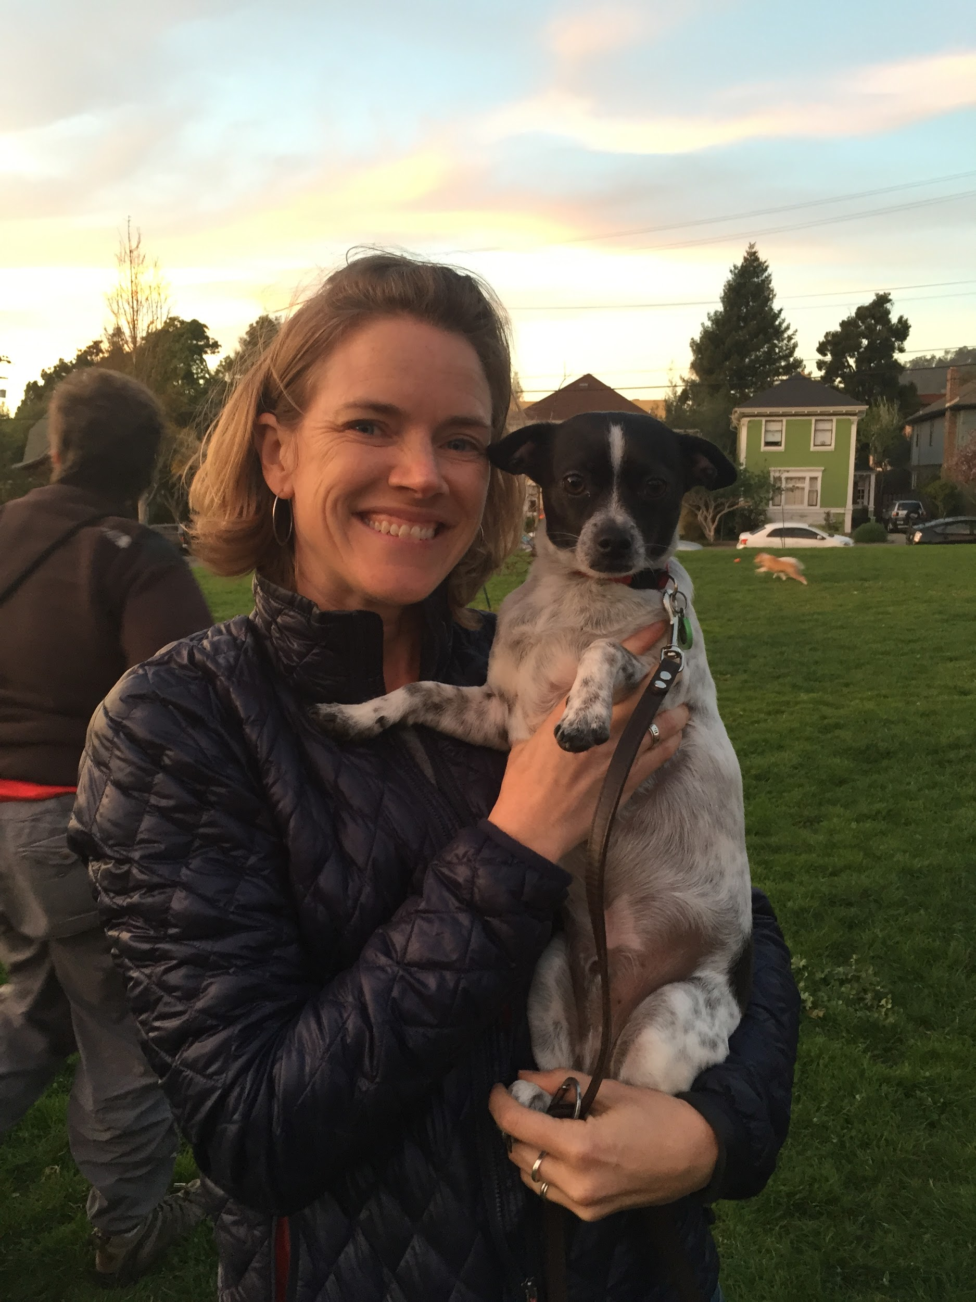

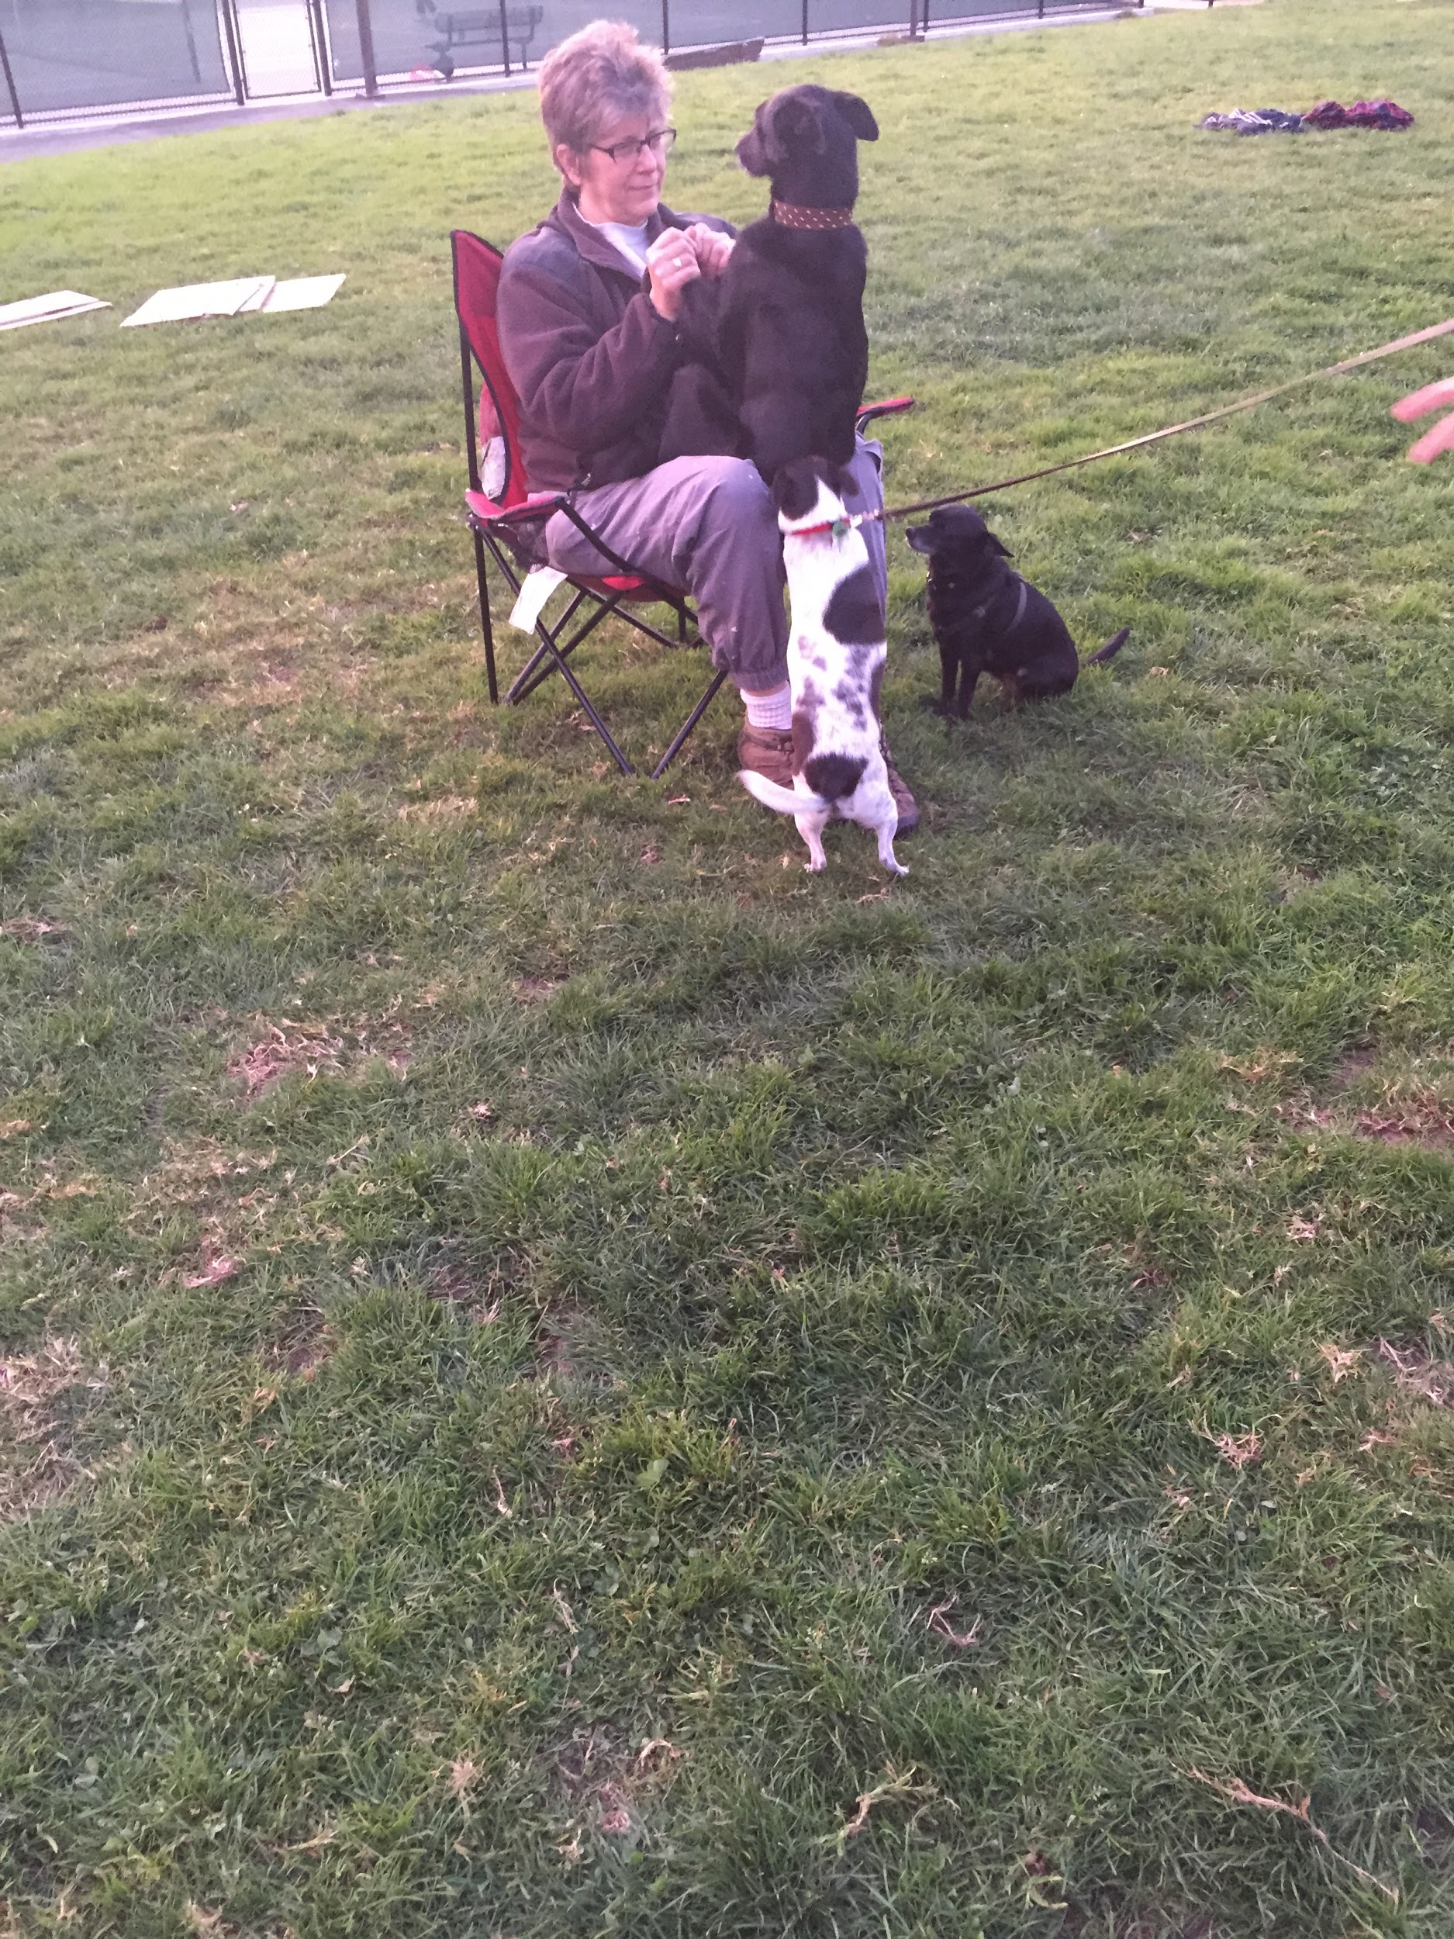

**Interview Note #5 (Garrett & Steven)**

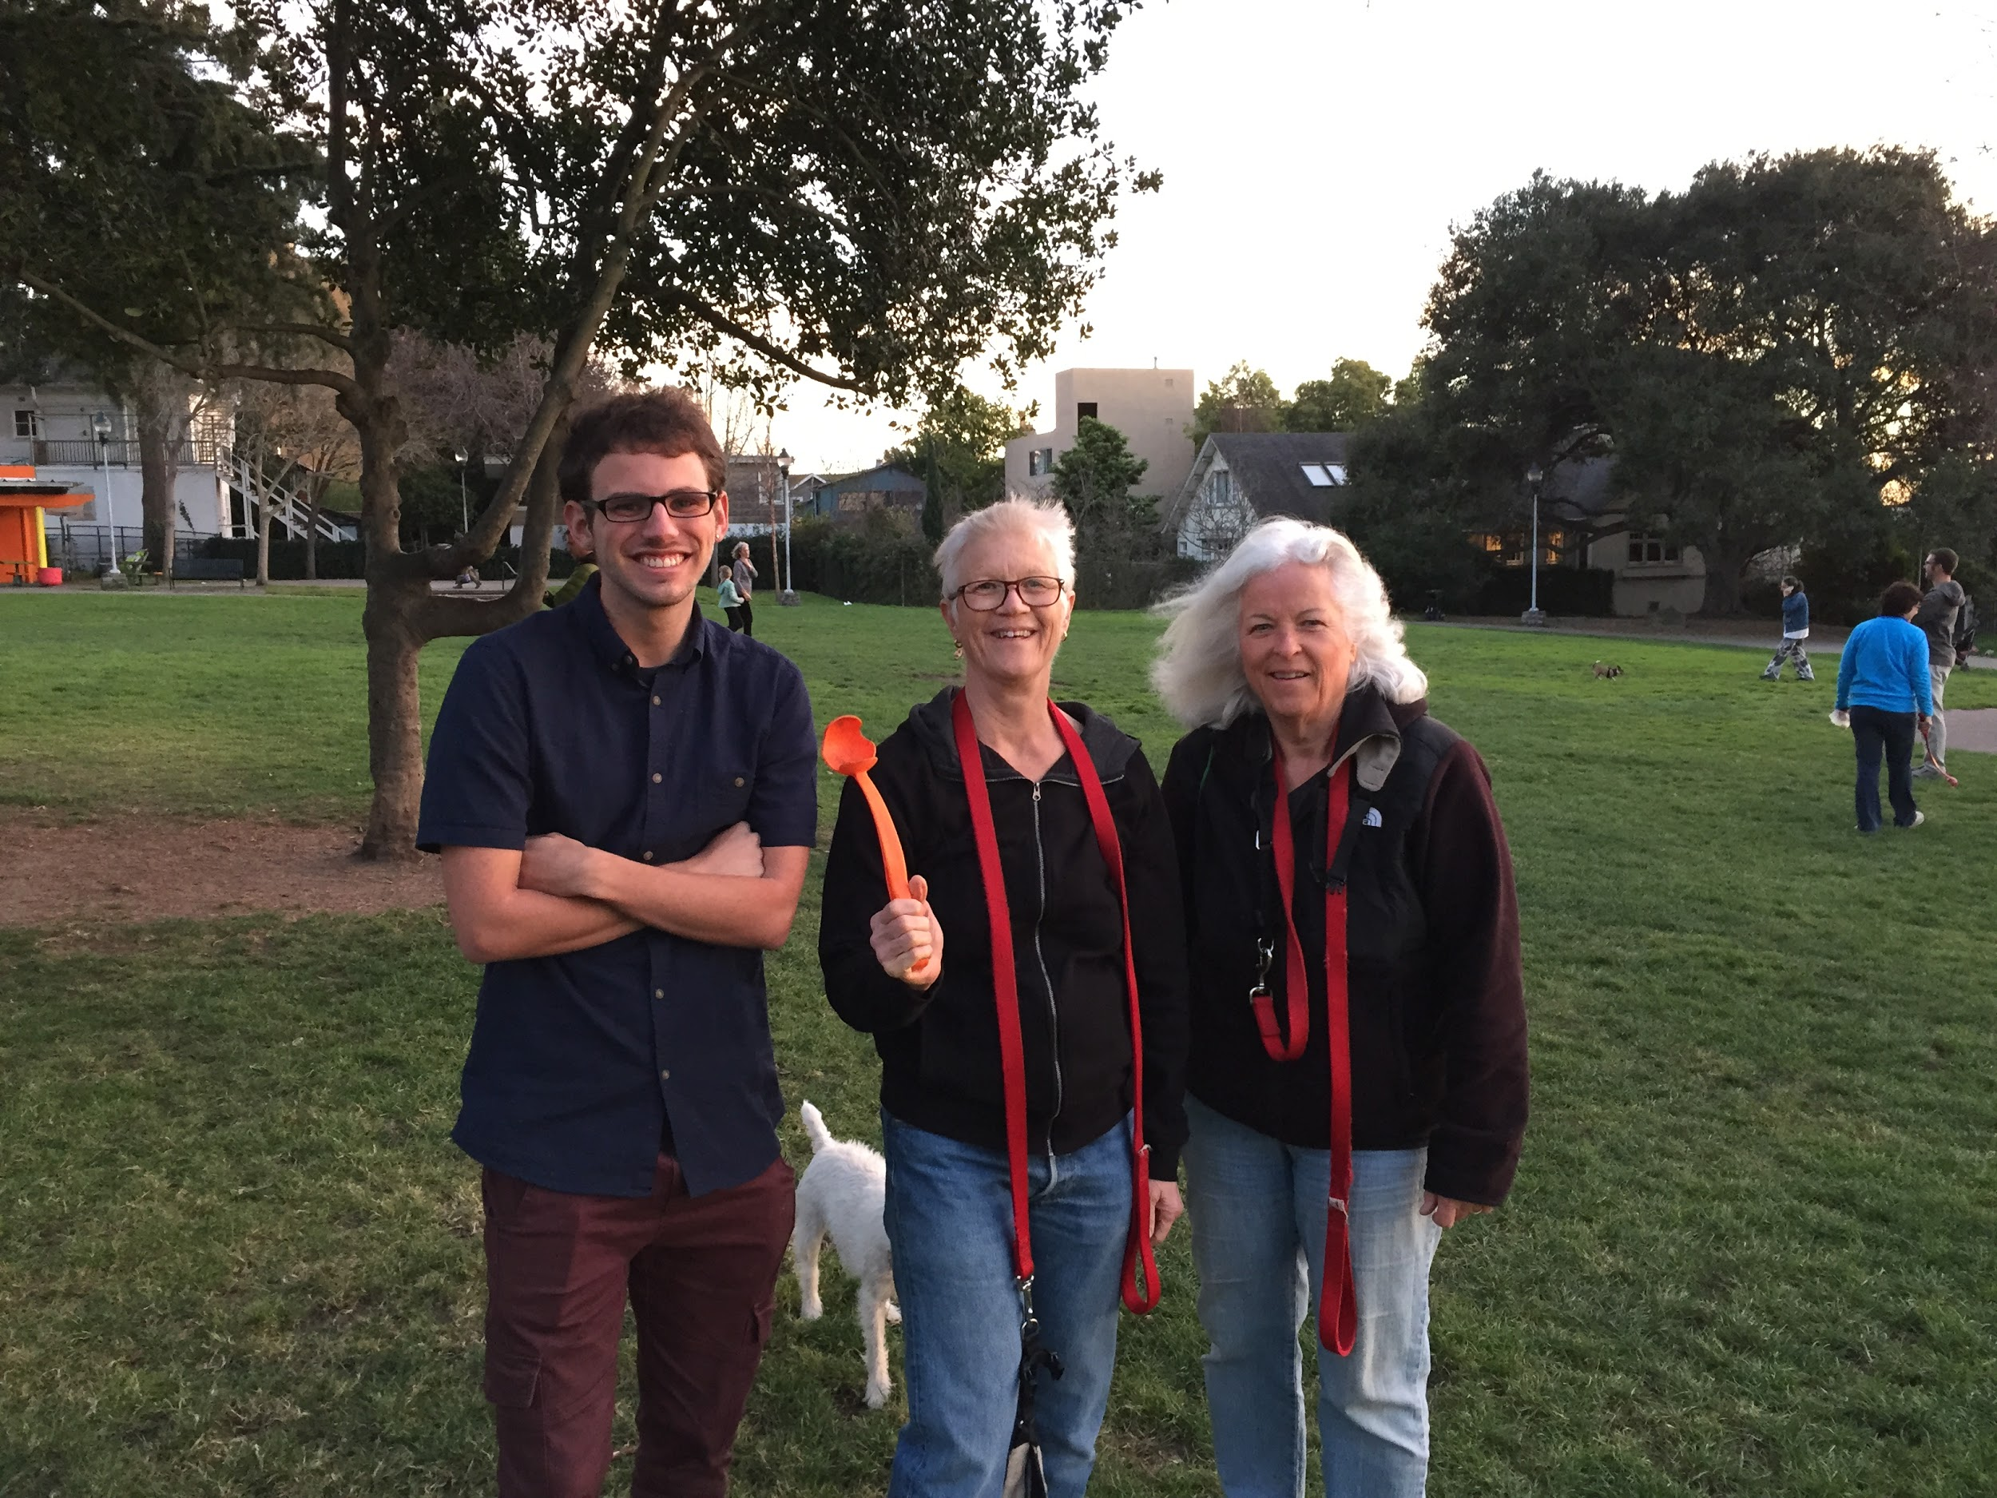

Background

* Own two terriers
* Vegan
* Think of themselves as very connected with their animals
* Work from home
* Clearly interested in what happens to their dogs when they’re not there

Dog background

* Vegan too
* They share out of each others’ bowls while eating

Problems with dog ownership

* Anxiety when leaving
  + Many triggers, like the sound of keys, closing of doors, etc.
* Eating things they should not
  + Generally outside
  + Things like feces, plants and flowers, and even the siding of the house
  + They sometimes get sick from it
* Fighting between dogs (though their dogs are friendly with each other)
* Dog sitters and dog hotels
  + Curious about what actually happens when other people are taking care of their dogs
  + Interested in the idea of a “nanny cam for your dog”

This older couple owns two terriers and think of themselves as well-connected with animals in general. They have trouble dealing with their dogs’ separation anxiety, which is triggered when they pick up their keys, close certain doors, etc.. They wish they had a way to prevent their dogs from eating things that they should not. They are concerned about what happens when they leave their dogs with dog sitters or at a kennel. They expressed interest in the idea of a “nanny cam for your dog” for when one leaves their dogs with someone else.

**General Description**

Most dog owners spend a significant portion of their time away from their pets. This means they are unable to interact with their pet, monitor them, or be alerted in case of unwanted events. With our smart dog collar, users can see live sound and video from their pet as well as location and various behavioral data, such as physical activity, barking, and eating activity. This is especially important for dog training, as being away from the home presents a challenge when trying to train a pet. With our smart collar, the owner can receive alerts or set automatic actions, like playing a loud noise, in the case of unwanted behavior such as prolonged barking, leaving designated areas, or even chewing up shoes.

**Team Members**

**\*\*\*Each team member’s name and a short description (one sentence per person at most) of how they contributed to this assignment\*\*\***

**Andrew Blum -- Analysis of 6 tasks, interviews, idea and tasks, general description**

**Anna Goodman -- Interviews, is the team mascot, 11 task analysis questions**

**Eric Quach -- Interviews, competitive analysis, description of interface design**

**Garrett Fidalgo -- Interface design scenarios, interviews, task brainstorming**

**Steven Baum -- Interviews, Analysis of 6 tasks, task brainstorming**

**Task Analysis Questions**

**1. Who is going to use system?**

Dog owners who spend time away from home but want to continue to train the dog when they aren’t at home. People that want to make sure that the dog isn’t running away from home, barking at the neighbors, or generally wreaking havoc when the owner is away.

**2. What tasks do they now perform?**

They currently have very minimal way of figuring out what the dog is up to while they are away. Currently, there exist some dog collars that have video, and some people have put up video cameras in their houses to keep eyes on their dogs. Some collars currently also have GPS tracking so you can find the dog if it gets out of the house, there are shock collars to keep dogs in range, but the interaction between the dog/collar and the owner while the owner is away is fairly minimal- most devices operate as you set them once and then forget about them.

**3. What tasks are desired?**

Users that we spoke to had interest in knowing what the dog was doing while they were away- specifically, if the dog was breaking its training. We talked to several dog owners that wanted to make sure the dog wasn’t barking too much, jumping on furniture, or running away from home.

**4. How are the tasks learned?**

The tasks all stem from curiosity about the dog’s current activity, so the tasks are learned mainly through that. Hopefully any solution we come up with is elegant enough to aid in the learning or how to monitor all of these things about your dog, but the task of monitoring should either stem from curiosity or necessity.

**5. Where are the tasks performed?**

Anywhere except when the person is with their dog. The only essential thing in this scenario is that the pet owners are away from their pets and therefore need a better way to keep track of what the pet is doing.

**6. What’s the relationship between user & data?**

In terms of long-term data, users will have access to the bark logs and GPS logs of the dog’s activity, as well as a track of the shocks that have been administered to the dog. Upon opening the application, the user can see the view from the camera, know whether or not the dog is barking, see where the dog is, and shock the dog if they want to. They also can play music to soothe the dog. The app will be able to be paired with a device only by knowing registration information on the collar, but also by having admin approval from the first person to register the collar (so random people can’t just pair a smartphone to your dog collar without approval).

**7. What other tools does the user have?**

The user should have a smartphone (as this is the way they will be able to use the companion application to interact with the device). Users that already have dogs already have a lot of equipment for the dogs (such as normal collars, leashes, some have bark/shock collars, some have shock collars for invisible fences, etc.). Many users we talked to also had a light to fasten to the collar in the winter when the dogs were out in the nighttime a lot.

**8. How do users communicate with each other?**

This isn’t a social activity, so users will only communicate with each other in certain scenarios. 1. Getting approval from the “administrator” account. 2. If the collar is having a problem, they might need to contact tech support to get it all sorted out. Most significantly, this is a way for dogs and owners to interact, so even though the dog won’t be the user of the product, the dog *will* be the wearer of the collar.

**9. How often are the tasks performed?**

This varies across users. Some people are away from their dog for many hours every day, and some people are only away from their dog if they go on vacation and want to check up on the dog and make sure that s/he is being taken care of. Frequency could vary from daily/very consistently to every once in a while (but most likely, if they’d be buying this product, they would be on the more frequent side of things).

**10. What are the time constraints on the tasks?**

Ideally, all the tasks would be fairly quick and easy to do. When the owner is at work (or doing whatever they are doing while they’re away from the dog), they don’t want to be checking the application constantly, or have it be a hassle to do so (one woman we spoke to actually told us that having the ability to see the dog on video might stress her out, if she could do it constantly).

**11. What happens when things go wrong?**

Without a way to check up on the dog, the worst-case scenario would be the dog running away from home and the owner not knowing until possibly hours later, when they returned from work. In the hours between the dog getting out and the owner knowing, the dog could have gotten miles away from home, seriously limiting the chances of finding the dog again.

**Analysis of Tasks**

1. **Hard:** Observe dog’s behavior from a remote location. The most common variation of this scenario would involve the dog being at home, in whatever area the owner keeps it while out, and the owner being away at work, running errands, or some other out-of-home location. Whether through a first-person or static viewpoint, users could access footage of the dog through the companion application anytime they wished. Currently, there are few ways to do this and it is a difficult task. A user would have to install an expensive home camera system such as Dropcams in every room as well as outside, and then check each individually to find their pet. With our solution a user could see what their pet was doing immediately upon launching the app, making this task easy.
2. **Hard:** Train the dog from a remote location. In a reasonable and humane manner, users would be able to apply particular stimuli to the dog in the event of the dog exhibiting any undesirable behavior. This form of classical conditioning would, over time, reduce instances of such behavior through continued stimulus/response pairings. The user could either shock the dog or play a loud, unpleasant sound either through the application whenever they wish, or by configuring thresholds based on behavior alerts, such as the dog leaving a certain geographical area or barking for more than a certain period of time. This is currently a difficult task as most training methods either involve the user being present or are extremely narrow in scope, such as a shock collar. Our solution provides a wider range of activity tracking and allows remote user monitoring and intervention so users can train their pet both remotely and flexibly in any manner they wish, just as if they were present. This is still not fully automated and requires some level of user interaction to get the full benefit, so it is a medium difficulty task with our solution.
3. **Medium:** Ascertain the dog’s location. In instances where the dog’s location is unknown, users can find the whereabouts of the dog at any point in time, particularly when the user is separated from the dog by a substantial distance. Currently, there are stand alone GPS tracking collars, as well as simpler solutions such as using a bell or looking searching the area for a while. Depending on the dog and the situation, it can be quite an annoyance, but not daily, and is usually surmountable. As such, this task is currently of medium difficulty for users. With our solution, the dogs location would be available in the application to a very precise degree, making locating the dog easy.
4. **Medium:** Investigate issues of persistent barking when the user is not present to witness it. When the user is out of the house and issues arise with neighbors experiencing noise disruption from the dog’s barking, the user can validate that the noises were, in fact, the dog. The user can also confirm said barking occurred at the times alleged by the neighbor and have logs of the barking as proof if needed for any reason. Currently, a user would have to be home or rely on accounts and reports from others such as family, neighbors, house cleaners, etc. This can be very difficult, though depends on the owners living situation. Because there are other viable solutions that people employ that are not too difficult or involve purchasing other products, we rate this as a medium difficulty task. Our solution, however, makes this task easy. Barks are automatically logged and the user can choose to be notified or have automatic actions performed based on these alerts.
5. **Easy:** Keeping track of the dog’s fitness and activity levels. Depending on the breed of dog and the expected levels of activity needed to maintain a healthy lifestyle, users can track how much the dog has moved about, particularly with regards to going on walks. This is especially useful in cases where the dog is under the prolonged supervision of someone other than the owner - pet-sitters and kennel owners, for instance. Currently, most owners have a pretty good idea of their dogs activity levels, as they have primary involvement in their dogs activities such as walks and hikes, so this is regarded as an easy task. However, from interviewing dog owners it was clear that some wanted this to be even easier, as well as recorded for them. Our solution provides some information that is currently more difficult for owners to obtain (exactly how much did Fido run around in circles in the backyard today while I wasn’t home?), finer grain information (step count and mileage on a walk for example), and automatic logging of this information making a basic task of dog ownership even easier.
6. **Easy:** Observing and tracking the dog’s eating patterns, with regards to the dog’s intake of both wanted and unwanted foods. For actual and intended dog food, the user can limit the dog’s access to food based on a premeditated schedule. For cases of non-intended object consumption, users can monitor the situations leading up to the eating, and if desired, administer behavioral reprimanding to the dog to prevent further action. Currently, most owners feed only at designated times, and are aware of what and how much their dog eats, so this basic task of pet ownership is considered fairly easy. However, some owners free feed and would like to know how much their dog eats, as well as when. Further, some dogs eat things they are not supposed to such as clothing or rugs, and while this is usually obvious for the owner, it is much more useful to know right away rather than once a user returns home or happens to go into that room. Performing this task with our solution is actually slightly *more* difficult than what most owners currently do as it requires setting up, checking, and acting on alerts. However, it also provides far more functionality than traditional methods.

**Interface Design**

**Scenarios**

(Note: App screens are only representative of the app’s featureset, they do not reflect the full app UI)

1. The user wants to observe their dog from a remote location. This scenario assumes that the user has already set up the device (dog collar) with their mobile phone.

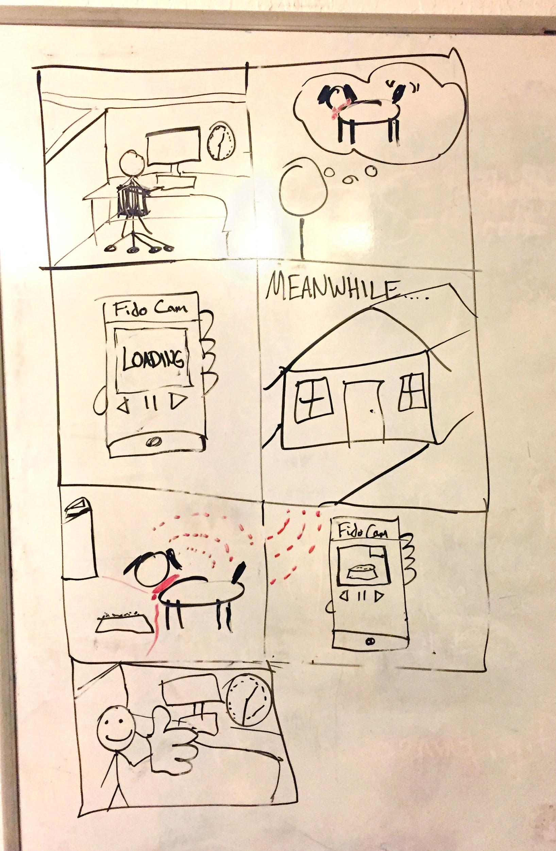

* 1. The owner is at work
  2. The user wants to know what their dog is doing while they are away
  3. The user opens the app
  4. In the background:
     1. The app connects to a web service which simultaneously connects to the dog collar device
     2. The dog collar device starts broadcasting video to the app
  5. The user can see video from the dog’s perspective

1. By default, the product alerts the user if their dog is barking persistently when they are not around. The user can choose to address the barking through the voice relay feature.

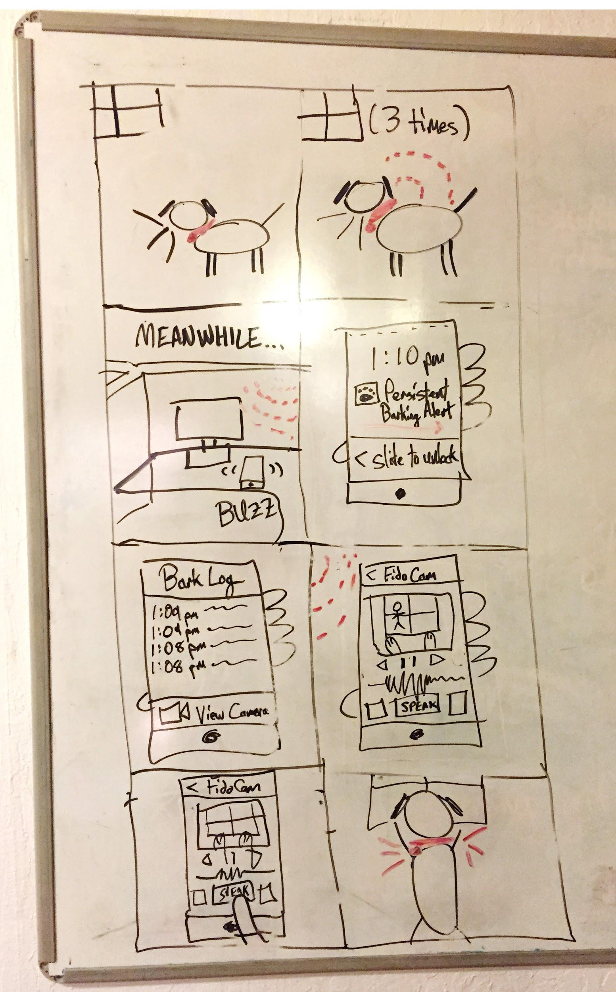

* 1. The dog begins barking persistently
     1. The dog collar device senses the audio activity
  2. The device sends a push notification to the user’s mobile device while they are at work
  3. The user receives a Persistent Barking Alert and opens the app
  4. The app displays a bark log and offers the opportunity to view the camera and history
  5. The owner views the camera
  6. The owner speaks to their dog via the camera interface
  7. The collar device plays the owner’s voice through its speaker

1. The user loses track of where their dog is and uses the app to find them.

.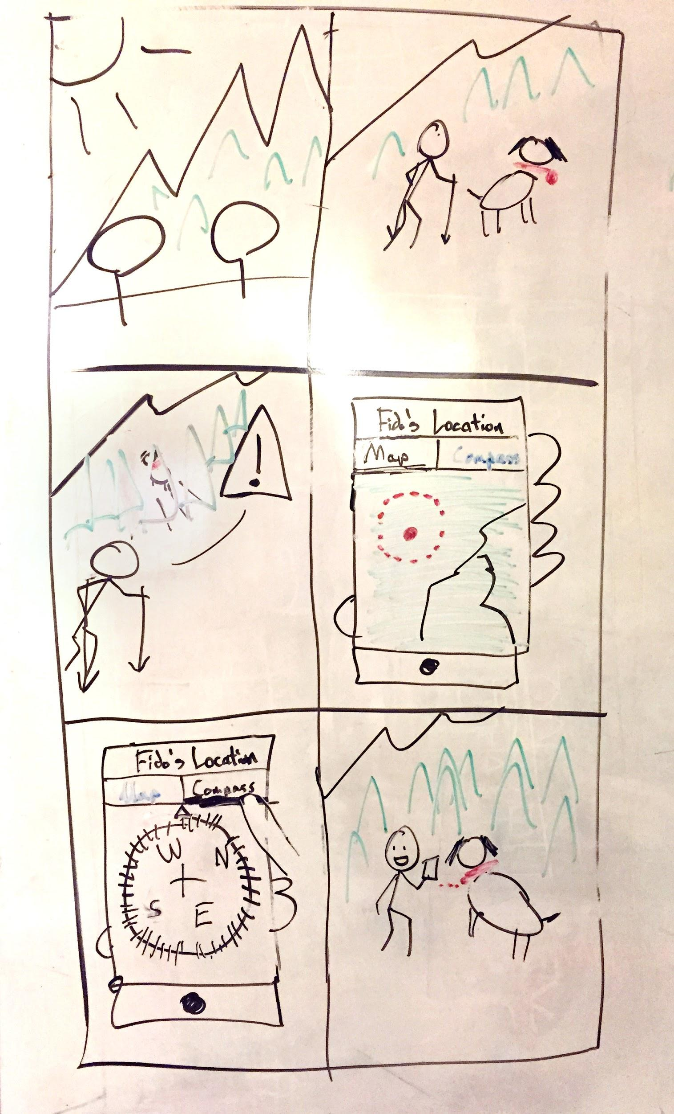

* 1. The user and their dog are hiking on a trail
  2. The dog runs off the trail
  3. The user opens the app and activates the collar device GPS
  4. The user browses the map to identify a coarse location
  5. The user selects the compass feature and searches for their dog
  6. The user and their dog are reunited

1. The users wants to know what the dog is currently doing and where it is at.

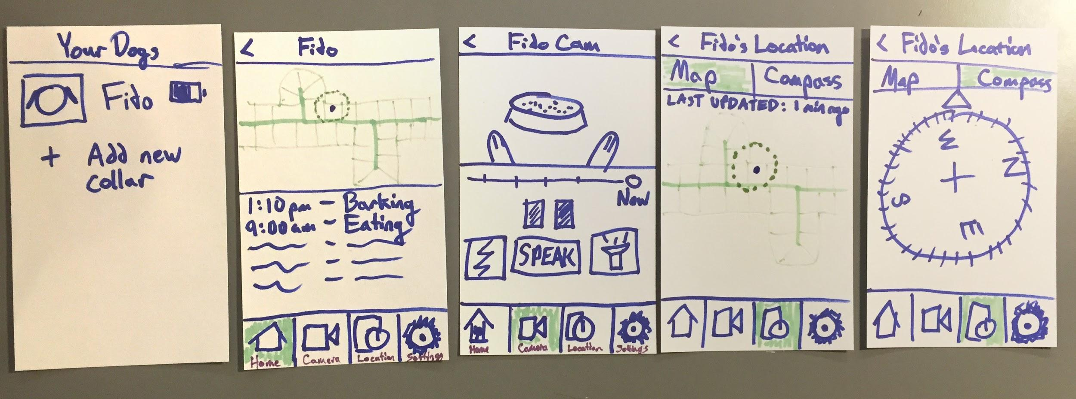

* 1. The user is taking a walk and the dog is supposed to be at home.
  2. The user opens the application.
  3. The user selects the dog.
  4. The user views a list of activities that the dog is doing.
  5. The user selects the camera feature and notices that the dog is eating.
  6. The user selects the map option in the location feature and locates the dog.
  7. The user selects the compass option in the location feature to find out which way his home is.

**Competitive Analysis**

**List of Competitors**:

· **Anysun’s Fashion Mini GPS Tracker:**<http://www.amazon.com/Fashion-Tracker-Locator-Tracking-Platform/dp/B00OVY6VHC>

· **Wuf - The World’s Smartest Dog Collar:**<https://www.kickstarter.com/projects/wuf/meet-wuf-the-worlds-smartest-dog-collar>

· **Tagg GPS Pet Tracker:**<http://www.amazon.com/Tagg-GPS-Pet-Tracker-Attachment/dp/B0077I42S4>

· **Motorola Scout 5000:**<http://www.cnet.com/products/motorola-scout-5000/>

· **Whistle:**<http://www.whistle.com/>

**Anysun’s Fashion Mini GPS Tracker**

**Target User Group:** The target user group of Anysun’s Fashion Mini GPS tracker focuses on owners with small dogs and only want GPS tracking. Our application focuses on dog owners who want to monitor a dog’s activity through live video feeds and GPS, and train their dogs away from home.

**Functionality:** This tracker provides SMS google tracking and geofencing alerts, however we provide real time tracking, activity monitoring, two-way audio, sound and video feed, vibration motor, barking notifications, night lights, and automatic training mechanisms.

**Usability:** This dog collar succeed in the fact that it is waterproof, but fails to provide a good way to track dogs. Our app avoids the issue of SMS google tracking by providing users the ability to track their pets in real time.

**Wuf : The World’s Smartest Dog Collar**

**Target User Group:** The target user group of the Wuf focuses on dog owners who want to monitor a dog’s activity through GPS and communicate by voice when away from home. Our application focuses on dog owners who want to monitor a dog’s activity through live video feeds and GPS, and train their dogs away from home.

**Functionality:** While the Wuf has activity monitoring, GPS, two-way audio, and geofencing, we provide all of that plus a live sound and video feed, vibration motor, barking notifications, night lights, and automatic training mechanisms.

**Usability:** The Wuf succeeds in the fact that it provides its users advance analytics on physical activity and unlimited access to location tracking and data transfer, but it comes at a monthly cost. This becomes a usability issue when a dog is lost, because a person not paying monthly, will have to go through the trouble of upgrading. Our service is different for it is free to use and the user only has to pay for the collar, making it seamless for users.

**Tagg GPS Pet Tracker**

**Target User Group:** The target user group of the Tagg GPS Pet Tracker focuses on dog and cat owners who want to track their pet’s location in real time and monitor their everyday physical activity. Our application focuses on dog owners who want to monitor a dog’s activity through live video feeds and GPS, and train their dogs away from home.

**Functionality:** While the Tagg has activity monitoring and live GPS feeds, we provide both plus a live sound and video feed, vibration motor, barking notifications, night lights, and automatic training mechanisms.

**Usability:** The Tagg succeeds in the fact that it provides users activity snapshots and real time GPS tracking, but it fails that the users have to charge the device every night. Our device will have a battery pack that can be removed without having to remove the collar and can be charged every three days.

**Motorola Scout 5000**

**Target User Group:** The target user group of the Motorola Scout 500 focuses on dog owners who want to monitor their dog through GPS and video. Our application focuses on dog owners who want to monitor a dog’s activity through live video feeds and GPS, and train their dogs away from home.

**Functionality:** The Scout 5000 has live video streaming, GPS tracking, geofencing, and the ability to talk to your dog. Our device does all of that and has a vibration motor, barking notifications, activity monitoring, night lights, and automatic training mechanisms.

**Usability:** The Scout offers free live video streaming, however only through wi-fi. Our collar is synced through wi-fi but has a backup mechanism that allows users to monitor their pets through LTE internet.

**Whistle**

**Target User Group:** The target user group of the Whistle focuses on dog owners who want to track solely a dog’s activity and rest. Our application focuses on dog owners who want to monitor a dog’s activity through live video feeds and GPS, and train the dog away from home.

**Functionality:** The Whistle has in-depth activity and rest monitoring, while our device does that plus has a sound and video feed, real time GPS tracking, vibration motor, barking notifications, and automatic training mechanisms.

**Usability:** The Whistle succeeds in the fact that it is waterproof, needs to be recharged every ten days, and has wireless data syncing, but it fails to allow you to change dogs or reset the device once you have set it up. Our device solves this issue by allowing users to track any dog and multiple dogs on one device.

**Summary:** After reviewing the applications individually, the aspects that are well covered by the competition is GPS tracking and activity monitoring. However not a single collar has the ability to do GPS tracking, Geofencing, live video and sound feed, activity monitoring, night lights, automatic training mechanisms, and barking notifications all in one. We believe that parts of our proposed idea has been covered but not completely, and these difference are what makes our product unique.

In order of apperance :

1. Activity log showing logged actions, in this case “2:30, sprayed (citrus water in their face) for barking” etc
2. Home screen with slide out activity log on the right, photo caputure from dogs video feed as the main picture w/ time stamp when it was taken and then from left to right: HOME, VIDEO, and GPS buttons in the first row, with SPRAY WATER (or shock), AUDIO, and LOUD UNPLEASANT SOUND buttons in the row under that.
3. Live Video feed screen of dog digging a hole
4. GPS view of dogs location on a map
5. live view of dog barking at a mail man
6. someone “using” the app

